**Loan Predictor- Web Application**

* Team members :

Harsh Kumbhat

Atharva Sharma

Saransh Bankiwal

* Project description :

It is a web based application which helps the customers to know from which particular bank they could get a loan based on their details entered and get a report generated about the loan details i.e loan amount, interest rate and monthly installment.

* Screenshots 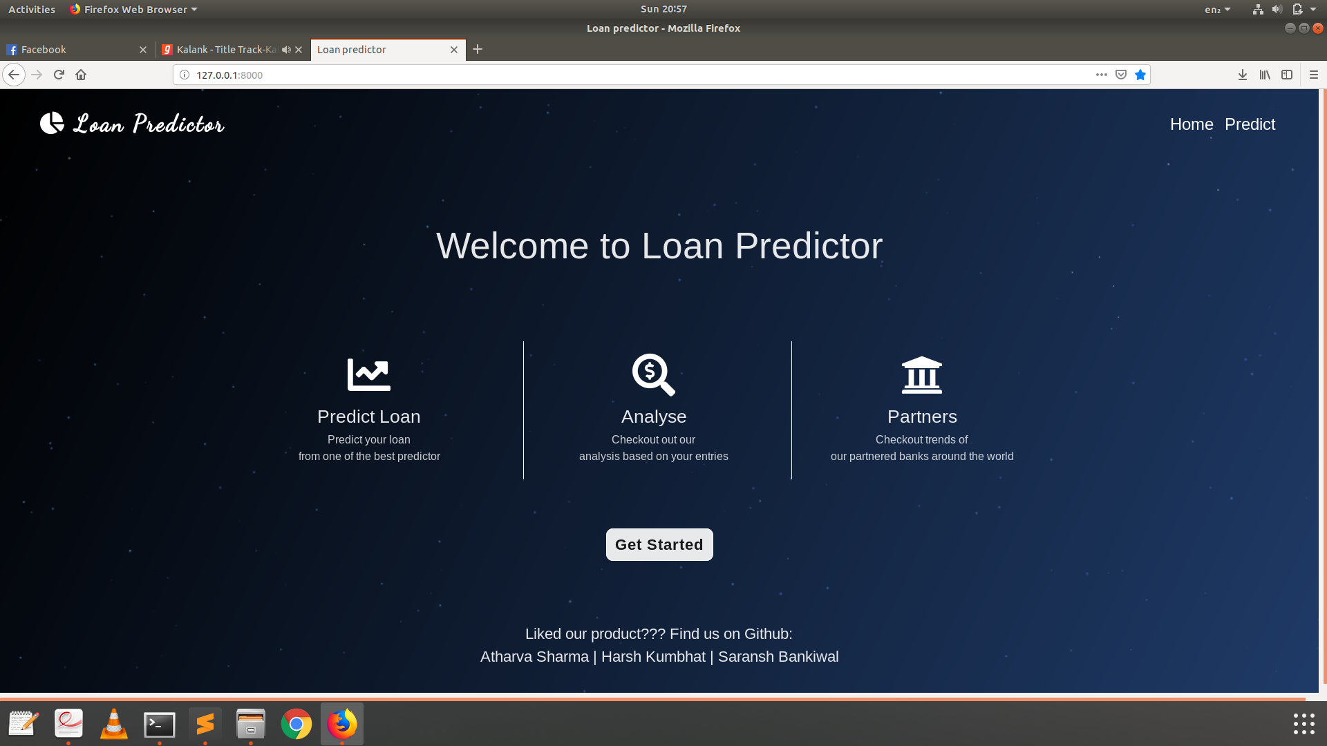

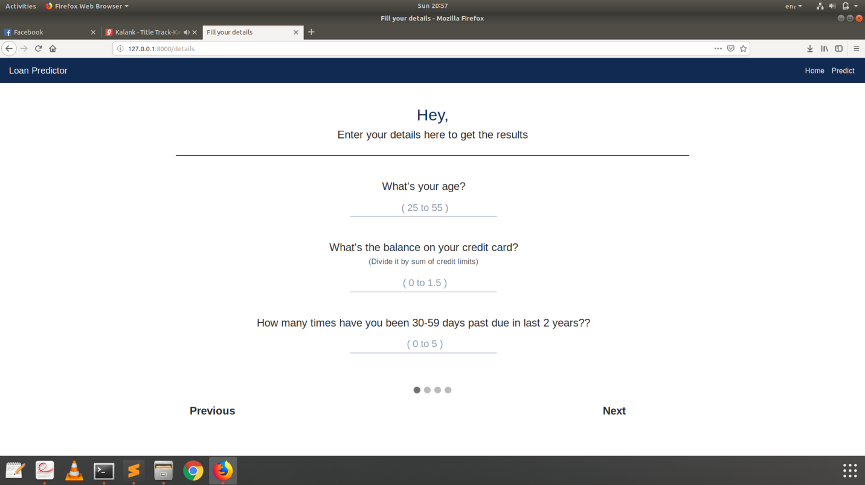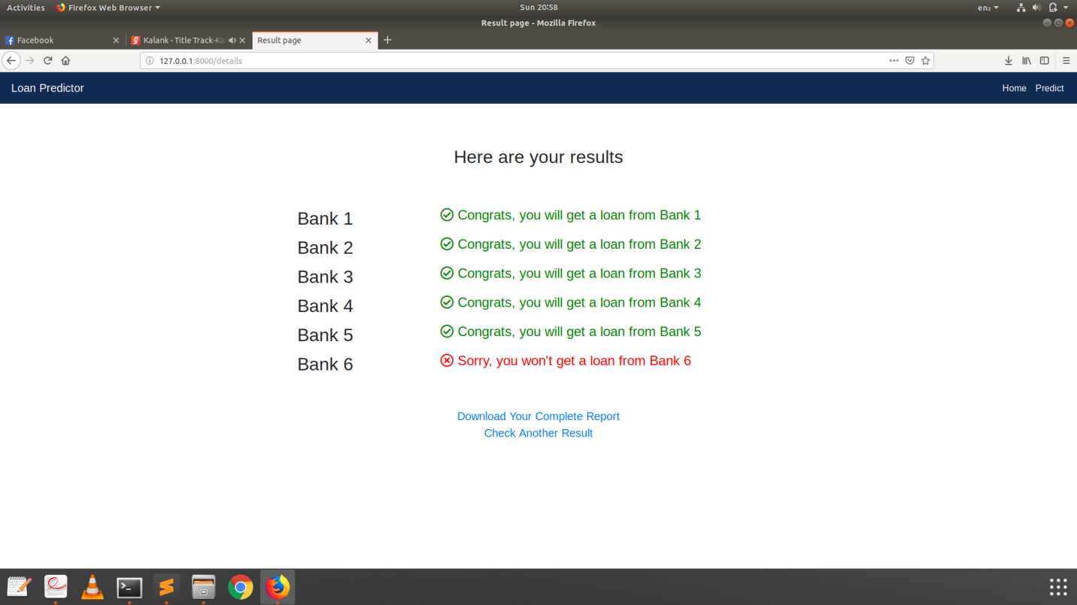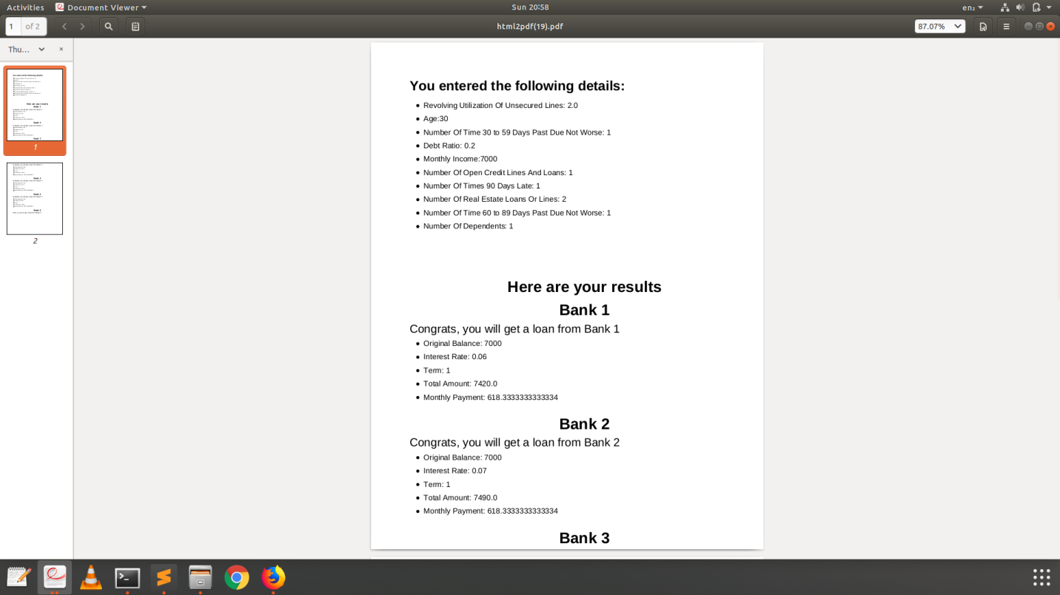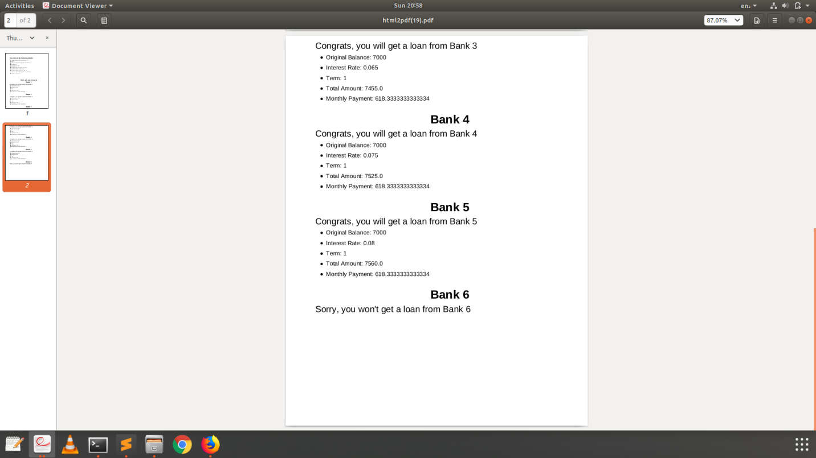

Installation process

To run the website follow the below steps:

1. Download and install DJANGO (Python Framework)
2. Clone the repository (<https://github.com/atharvasharma/Loan-Predictor-Web-Application>)
3. Run the Requirements.txt file and install all the dependencies. (pip install -r requirements.txt)
4. Navigate to the directory where manage.py file is present.
5. Open your terminal in that directory and type the following command: python manage.py runserver. This will run the server on your local PC
6. Open your browser and paste the address given in your terminal window.

* Technologies

Django

Scikit – Learn

Python (Numpy, Pandas and Pickle)

Matplotlib

HTML

CSS

Javascript

* Detailed description

The Loan Predictor Web Application is basically a banking application which has the following benefits for the following groups:

Banks:

It helps banks in deciding which particular customer should be given the loan so that he will not be a defaulter in the future. This is decided on by many factors including the person’s income, age, previous defaults, credit score, number of times he has been 30-60 days past or even worse, number of dependents etc.

Customers:

It helps the customers know that from which of the following 6 banks they would be getting a loan and at what particular interest rate. They can select the suitable bank among the available and get the full detailed report generated about the loan and the repayment details.

It uses machine learning models in predicting which bank will grant the loan or not to a customer based on his previous banking history and other details. We have tried various machine learning classifiers like SVM, Logistic regression, Random forest and Naive Bayes out of which Random Forest outperformed with the highest accuracy and best fit to the curve

Every bank uses the same model for prediction and have achieved an average accuracy of 94.4 % on the test set.

The website’s frontend part is designed using HTML, CSS and javascript. The backend is designed using Django. The model is implemented using python frameworks and libraries.